**TASK -04**

Failover and Redundancy

Failover is the automatic switching to a standby system or component when the primary one fails. This helps keep services running without interruption.

Redundancy means having extra or duplicate systems, devices, or paths available so that if one fails, others can take over seamlessly.

Together, they improve system reliability,availability, and fault tolerance, especially in networks, servers, and data centers.

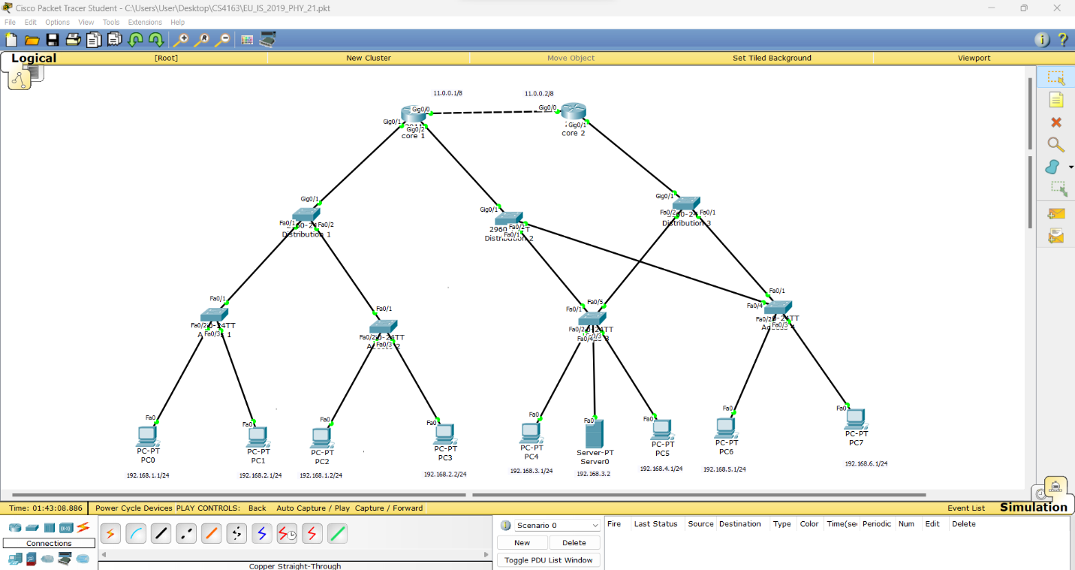

Standby Switch

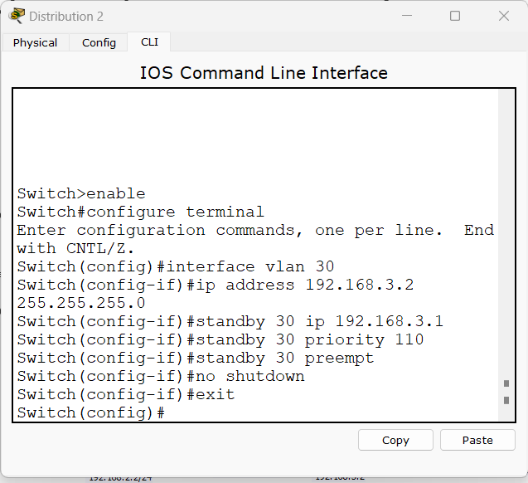

Index Number: PS2771

Registration Number: EU/IS/2019/PHY/21